Complaints and Feedback policy
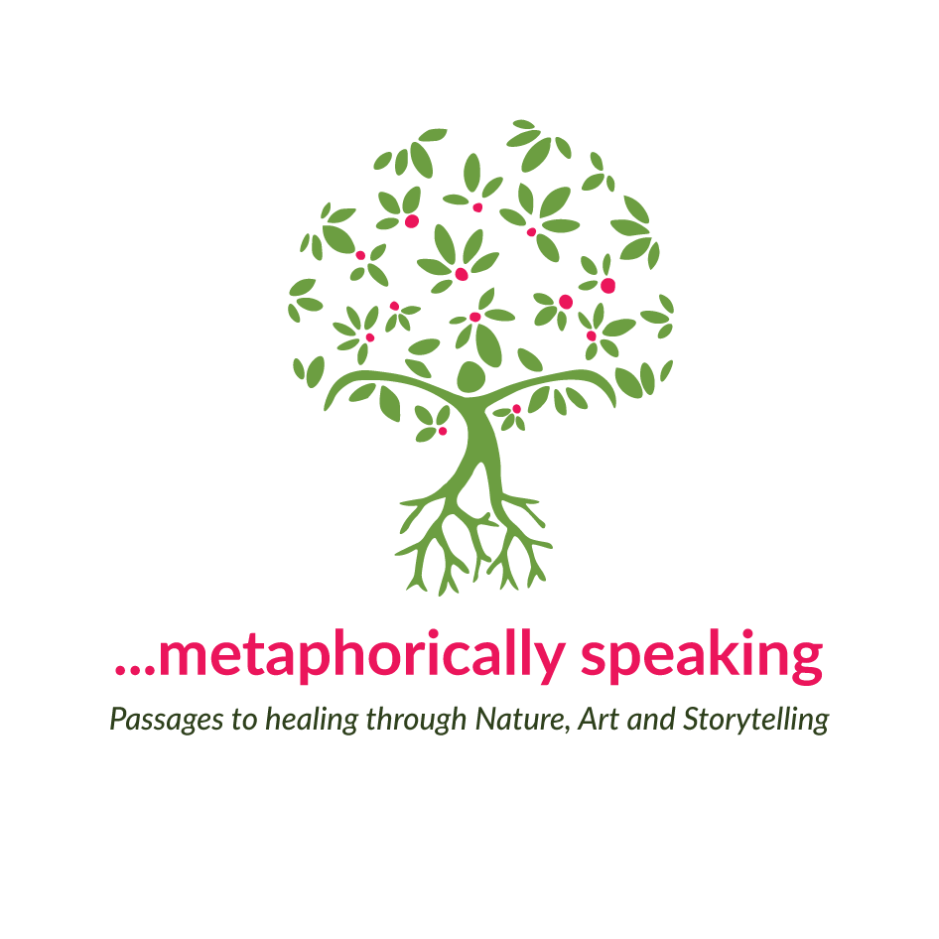

Overview
…metaphorically speaking is open and responsive to all feedback, complaints and suggestions for improvement. We value complaints as they assist us to improve our service. …metaphorically speaking is committed to consistent, fair and confidential complaint handling and to resolving complaints as quickly as possible.

Policy
- …metaphorically speaking will maintain a Complaints Register to ensure that all complaints are responded to in a timely and impartial manner.
2 …metaphorically speaking will ensure that all suggestions for improvement and complaints are recorded, considered and retained for process improvement purposes.
3 …metaphorically speaking encourages any person who has a complaint in relation to services or staff actions, to approach the appropriate staff member in the first instance, to try to resolve the issue. If further action is still required, the complaint can be made in writing using the Complaints and Feedback Form available from the website, and forwarded to the address provided for a formal response.
4 …metaphorically speaking will ensure that the complainant is informed of their right to have a support person or advocate present to assist or represent them during the complaints process.
5 …metaphorically speaking will address all complaints in a confidential manner. Only the person involved in making, investigating or resolving a complaint will have access to information about it.
6. Action to resolve the complaint will commence within 2 working days of the complaint being made.
8. Once a satisfactory course of action has been agreed upon by the complainant and …metaphorically speaking, the action(s) will be documented on the complaint form and copy provided to the complainant.
9…metaphorically speaking recognises the rights of a person to approach an external organisation such as the AASW, if the formal complaints procedure has not resolved the issue to their satisfaction.
10. Complaints will be analysed and monitored as part of a quality improvement process at …metaphorically speaking.

Lucy Van Sambeek
Metaphorically speaking
lucy@metaphoricallyspeaking.com.au
0417 927 657

