Tree Visualisation – 10 minutes
(read slowly with plenty of pauses – space for imagining.)
Remember, it is OK to adapt this visualisation to a way that fits comfortably with you. There is no right or wrong way to do this. If something doesn’t feel right for you, find another way.
I invite you to get comfortable in your chair. And if you feel OK about doing so, you may close your eyes, or alternatively just lower your eyes towards the floor with a softened gaze.
Become aware of your breathing. Just notice what it feels like, the sensation of the breath coming in through your nose or mouth, and out again. You may like to take a couple of deep breaths to help your body relax.
Now I invite you to imagine in your minds eye, a tree. It could be a tree you know in your garden, a favourite tree from your childhood or a tree you like to visit or look after.
Standing back at a distance, what does it look like, this tree?
Notice the height of the tree. And the canopy.
What does your tree look like with the sun shining through the leaves?
Imagine in your minds eye, the sensation of standing looking at your tree, feeling a connection with the earth underneath your feet. Just notice this feeling of being grounded.
Imagine all the roots from you tree, branching out and connecting with the other trees and all the other beings in the area. What is it like to see this connection?
Moving in closer to your tree now. What is it like to touch the bark? You may like to explore the sensation of touching the leaves on your tree. Where is it like to feel the breeze on your skin?
Now turn your attention to what you can hear? What sort of birds or animals can you hear? What does it sound like to walk around the base of your tree? Can you hear the sound of the breeze as it moves through the leaves?
Now turn the focus of your imagination to what you can smell? Is there a quality or texture to the air? Are there flowers, or fruit or leaves you can smell?
What is it like to lean up against your tree?
What is it like to sit on the ground at the base of your tree?
In your minds eye, find a way to be with your tree, that feels most comfortable for you.
What does it feel like in your body to just be with your tree?
You might like to bring your awareness now back to your breath.
And slowly bring your awareness back to the room.
And when you are ready, open your eyes.

If used in a group, ask the group to share ‘What are you noticing?’
This visualisation technique can be used anywhere at any time. You can bring your tree to mind whenever you need to. We have been told it is great when sitting in a medical waiting room, to allay anxiety or worry.
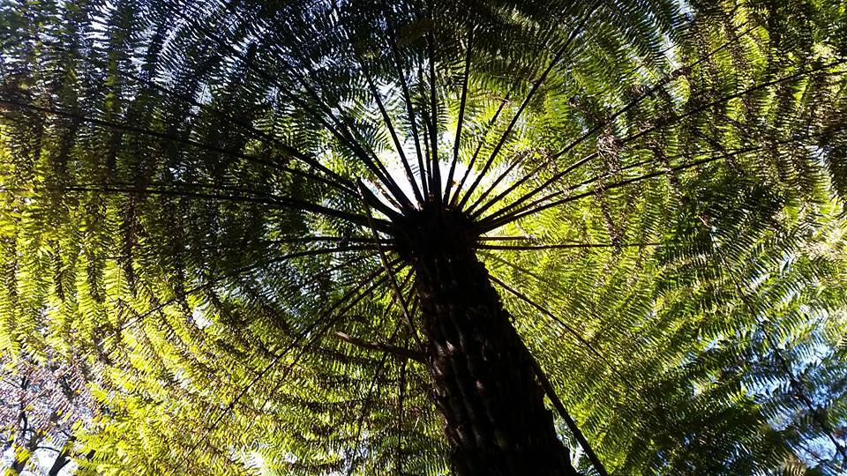
Exploring Nature Treasures – 5 minutes
I invite you to close your eyes and feel into the bag to choose an item. Any item will do, but perhaps something that feels pleasurable to you. Try to resist the urge to name or guess what it is you have chosen, but to simply sit with the feelings or sensations that arise as you explore it. Keeping your eyes closed, continue to explore your item in silence, using your sense of touch, as if you are discovering this thing for the very first time. We are going to do this for a couple of minutes.
I now invite you to open your eyes, and continuing exploring your item with your sense of sight, hearing, smell and any other way that feels right to you.
Does your treasure remind you of anything? If it could tell you a story, what would it say?
Spend a few more minutes just exploring your treasure in silence.
Reflection question - ‘What are you noticing’?

