Book Order Form
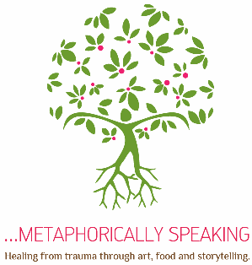

Supplier Details:
Name: | Metaphorically Speaking
Phone: | 0417 927 657
Website: | www.metaphoricallyspeaking.com.au
Email: | lucy@metaphoricallyspeaking.com.au
ABN: | 81403260514
Bank Details: | Name: Lucinda Van Sambeek  BSB: 065 901 Account: 11160464

Buyers Details:
Name:
Mailing Address:
Email:
Purchase details:
Qty | Item | Price ($)
 | Children’s picture book - ‘The Life of Tree’ @ $25 each
Plus Postage and Handling
Standard postage, $6.30 per book
Standard postage with signature/tracking, $10.10 per book
Parcel by road, $13.80 for 3-12 books
Parcel by road with signature/tracking, $16.75 for 3-12 books
Express Parcel $15.65 for 3-12 books
Express Parcel with signature/tracking $18.60 for 3-12 books
 | TOTAL
Special Requests/comments:

Completing your purchase:
- Please email this completed form to lucy@metaphoricallyspeaking.com.au
- Make payment via electronic funds transfer (account details provided above). Please use your surname as the Payment Reference.
- Once payment has been received, goods will be posted along with your receipt.

