Lucy Van Sambeek
Author and Social Worker
Darwin, Australia
www.metaphoricallyspeaking.com.au
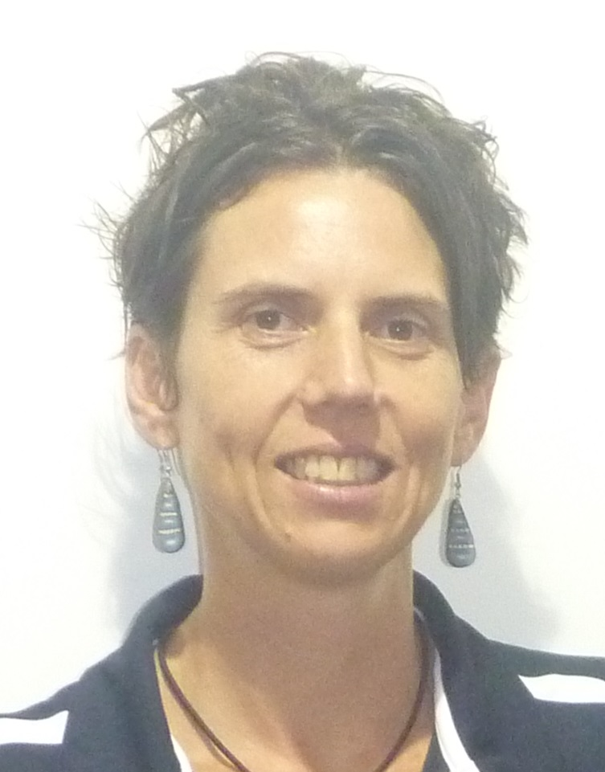
Lucy Van Sambeek is a trauma-informed, narrative art therapist whose passion is to achieve self determination and sustainable change for Aboriginal people in remote communities through a two-way learning approach.
Her special interest is promoting healing and recovery from trauma for women and children, and the prevention of trauma in the generation being born right now. After graduating with a Bachelor of Social Work with Honours in 2005, Lucy moved back to the Northern Territory and has worked in the Tiwi Islands and North East Arnhemland for the non profit sector for the last 10 years. During this time she has supervised fourth year social work students who have gone on to work with Indigenous communities, and mentored local women choosing to work by supporting their communities from within. Lucy has also earned a Certificate in Art Therapy with the Centre for Educational and Clinical Art Therapy. Her thesis explored appropriate art therapy approaches with Aboriginal Australians who have experienced trauma.
Lucy and her Aboriginal colleagues have presented their collaborative work and resources at the 2012 FRSA National Conference, Child Trauma Forum hosted by the NT Children’s Commissioner and the 2013 SNAICC Conference. “It Takes A Forest to Raise a Tree: Healing Our Children from the Storms in their Lives” is the first metaphorical, therapeutic resource Lucy developed in partnership with Aboriginal communities while working at Relationships Australia. Lucy also co-wrote and directed ‘The Seed of Life’ in Tiwi and Yolngu Matha, and acted in ‘One Family Tree’, video stories which engage women in a conversation about the effects of violence on children. “The Life of Tree” is Lucy’s first, self-published, children’s, therapeutic picture book.
Lucy has walked alongside Aboriginal women, men, children, families and communities who have been touched by the effects of domestic and family violence, child abuse, deep transgenerational grief and loss, alcohol and drugs and other traumas. She promotes healing and recovery through counselling, group work, bush camps and community development projects. Lucy is interested in exploring passages to wellbeing through mutually respectful relationships and collaboration with her Indigenous comrades. Her work brings together the best of Western science and knowledge, whilst respecting and engaging with Indigenous perspectives and world views.
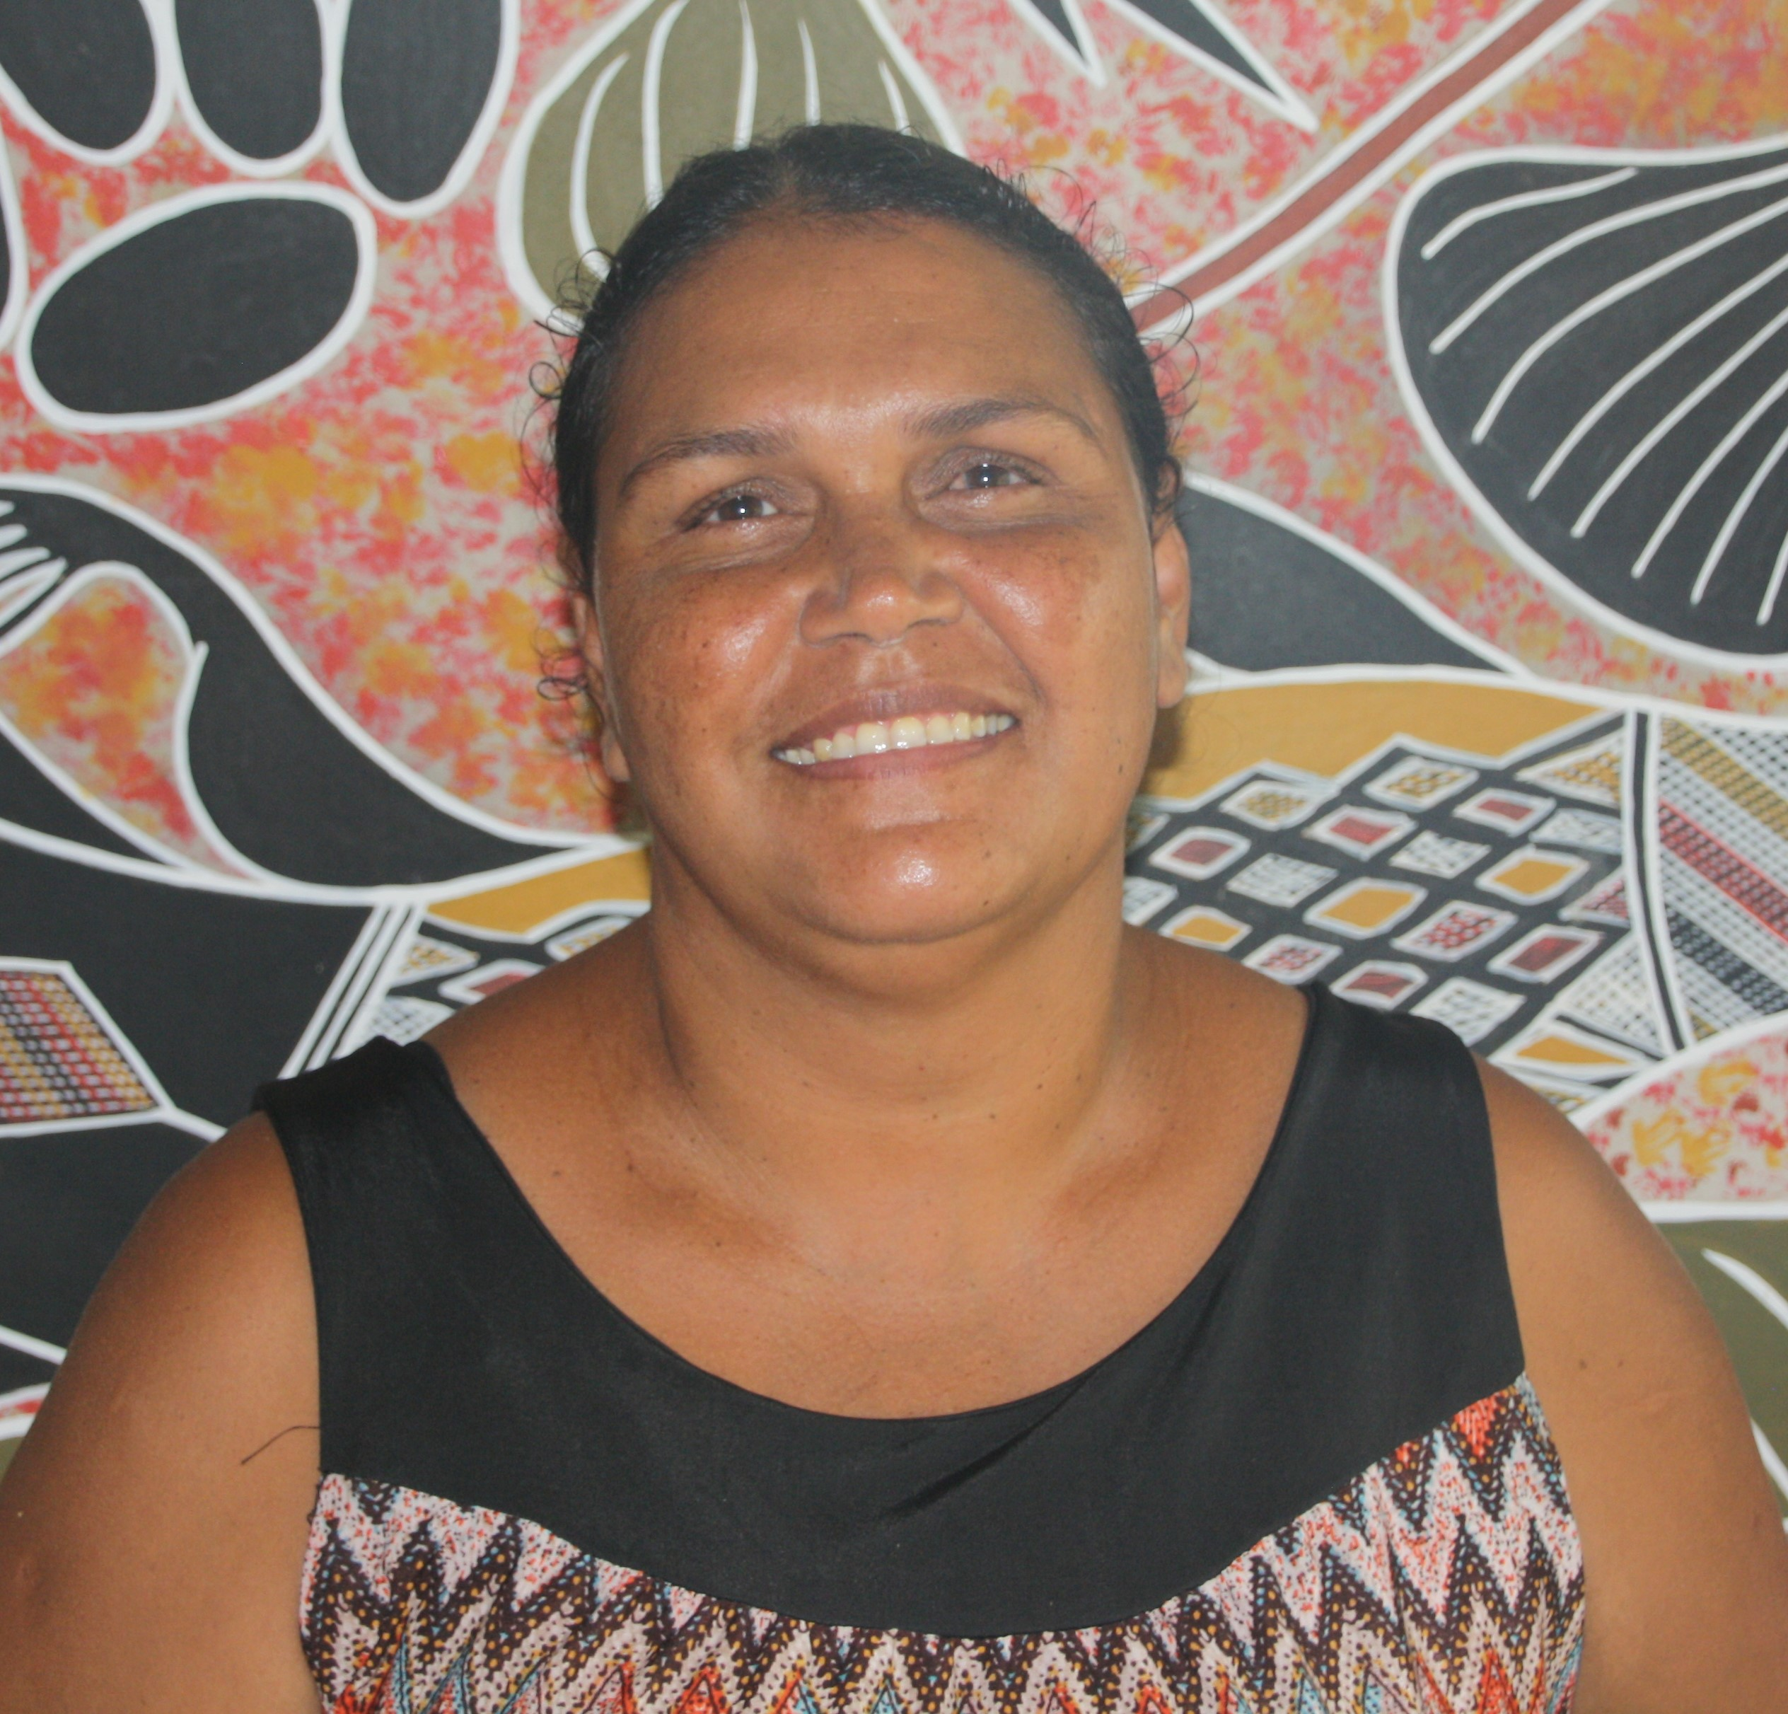

Christine Burarrwanga
Yolŋu artist and Illustrator
Darwin, Australia
Christine Burarrwanga is a Yolŋu woman from Yirrkala in NE Arnhemland. Christine made the hard decision to move away from her homeland to seek safety and refuge in Darwin and grow her independence. Despite this, she remains deeply connected to culture and country at Birang Birang in NE Arnhemland. The deeply spiritual and beautiful art of painting Christine inherited from her mother, along with knowledge, lore and stories, keep her strongly connected to her family and memories of country.
Christine’s priorities are to be a strong leader and role model for her children, giving them the best opportunity to access quality education whilst also fulfilling cultural responsibilities and traditions, by sending them back for regular visits with family at Galiwinku on Elcho Island and Yirrkala.
In 2015-17, Christine has been working with Lucy to produce ‘The Life of Tree” to assist Aboriginal children to give voice to their experience of violence.

