“It Takes A Forest To Raise A Tree: Healing Our Children from the Storms in their Lives”
A new talking tool for Aboriginal women with children who experience violence or other trauma in their lives
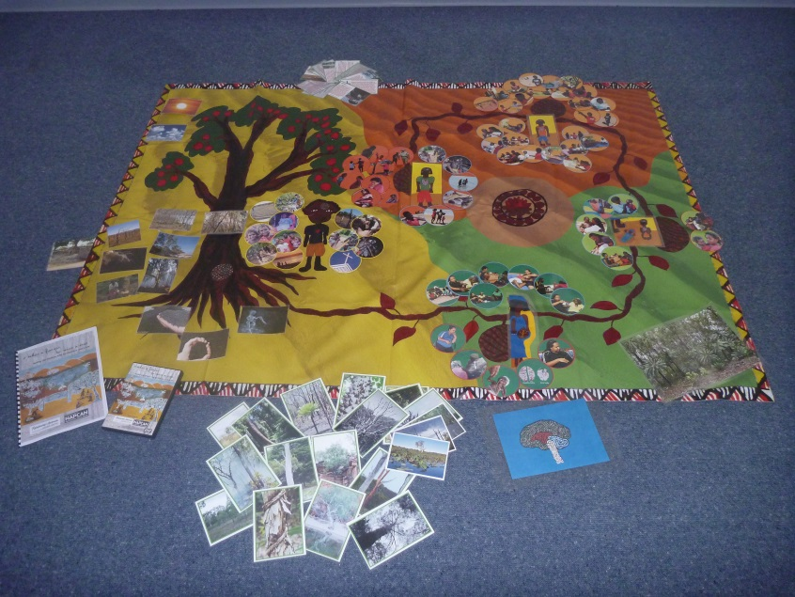
This resource was developed through a process of consultation with Elders and women on the Tiwi Islands and NE Arnhemland in response to worries for their children and grandchildren. Much of their concerns related to children’s responses to witnessing domestic and family violence, alcohol and substance misuse in their families, intergenerational and personal grief and loss issues, child abuse or neglect and other traumatic events. Lucy Van Sambeek from the RANT Children’s Therapeutic Team worked alongside Aboriginal Child and Family Support Workers to find ways of inviting women into safe and non-blaming conversations which explore the effects of trauma on children, with a particular focus on harm to the growing brain.
This talking tool takes the metaphor of a tree (from narrative therapy) as a pathway to talk about what trees need to grow strong and healthy, the effects of storms on trees and ways they recover after storms have passed. This opens the way for dialogue about what children need to grow strong and healthy, the effects of violent storms on children and what families and communities do to promote healing and recovery. We have found that using tree stories to talk about our families is a safe way of engaging women in a conversation about difficult times in their lives.
Here is what others are saying about this talking tool.
“Sections of [One] Family tree are a good stimulus for discussion about what is OK parenting and also how children seek and obtain what we call positive and negative attention. Also the material on brain development in The Seed of Life, we communicate in an interactive way but it is great to have locally produced resources including in language and to have a range of ways of introducing the information and ideas.” - Sarah Mares, Consultant Child and Family Psychiatrist & Senior Research Fellow, Centre for Child Development and Education, Menzies School of Health Research, Darwin
The “It Takes a Forest…” talking tool consists of
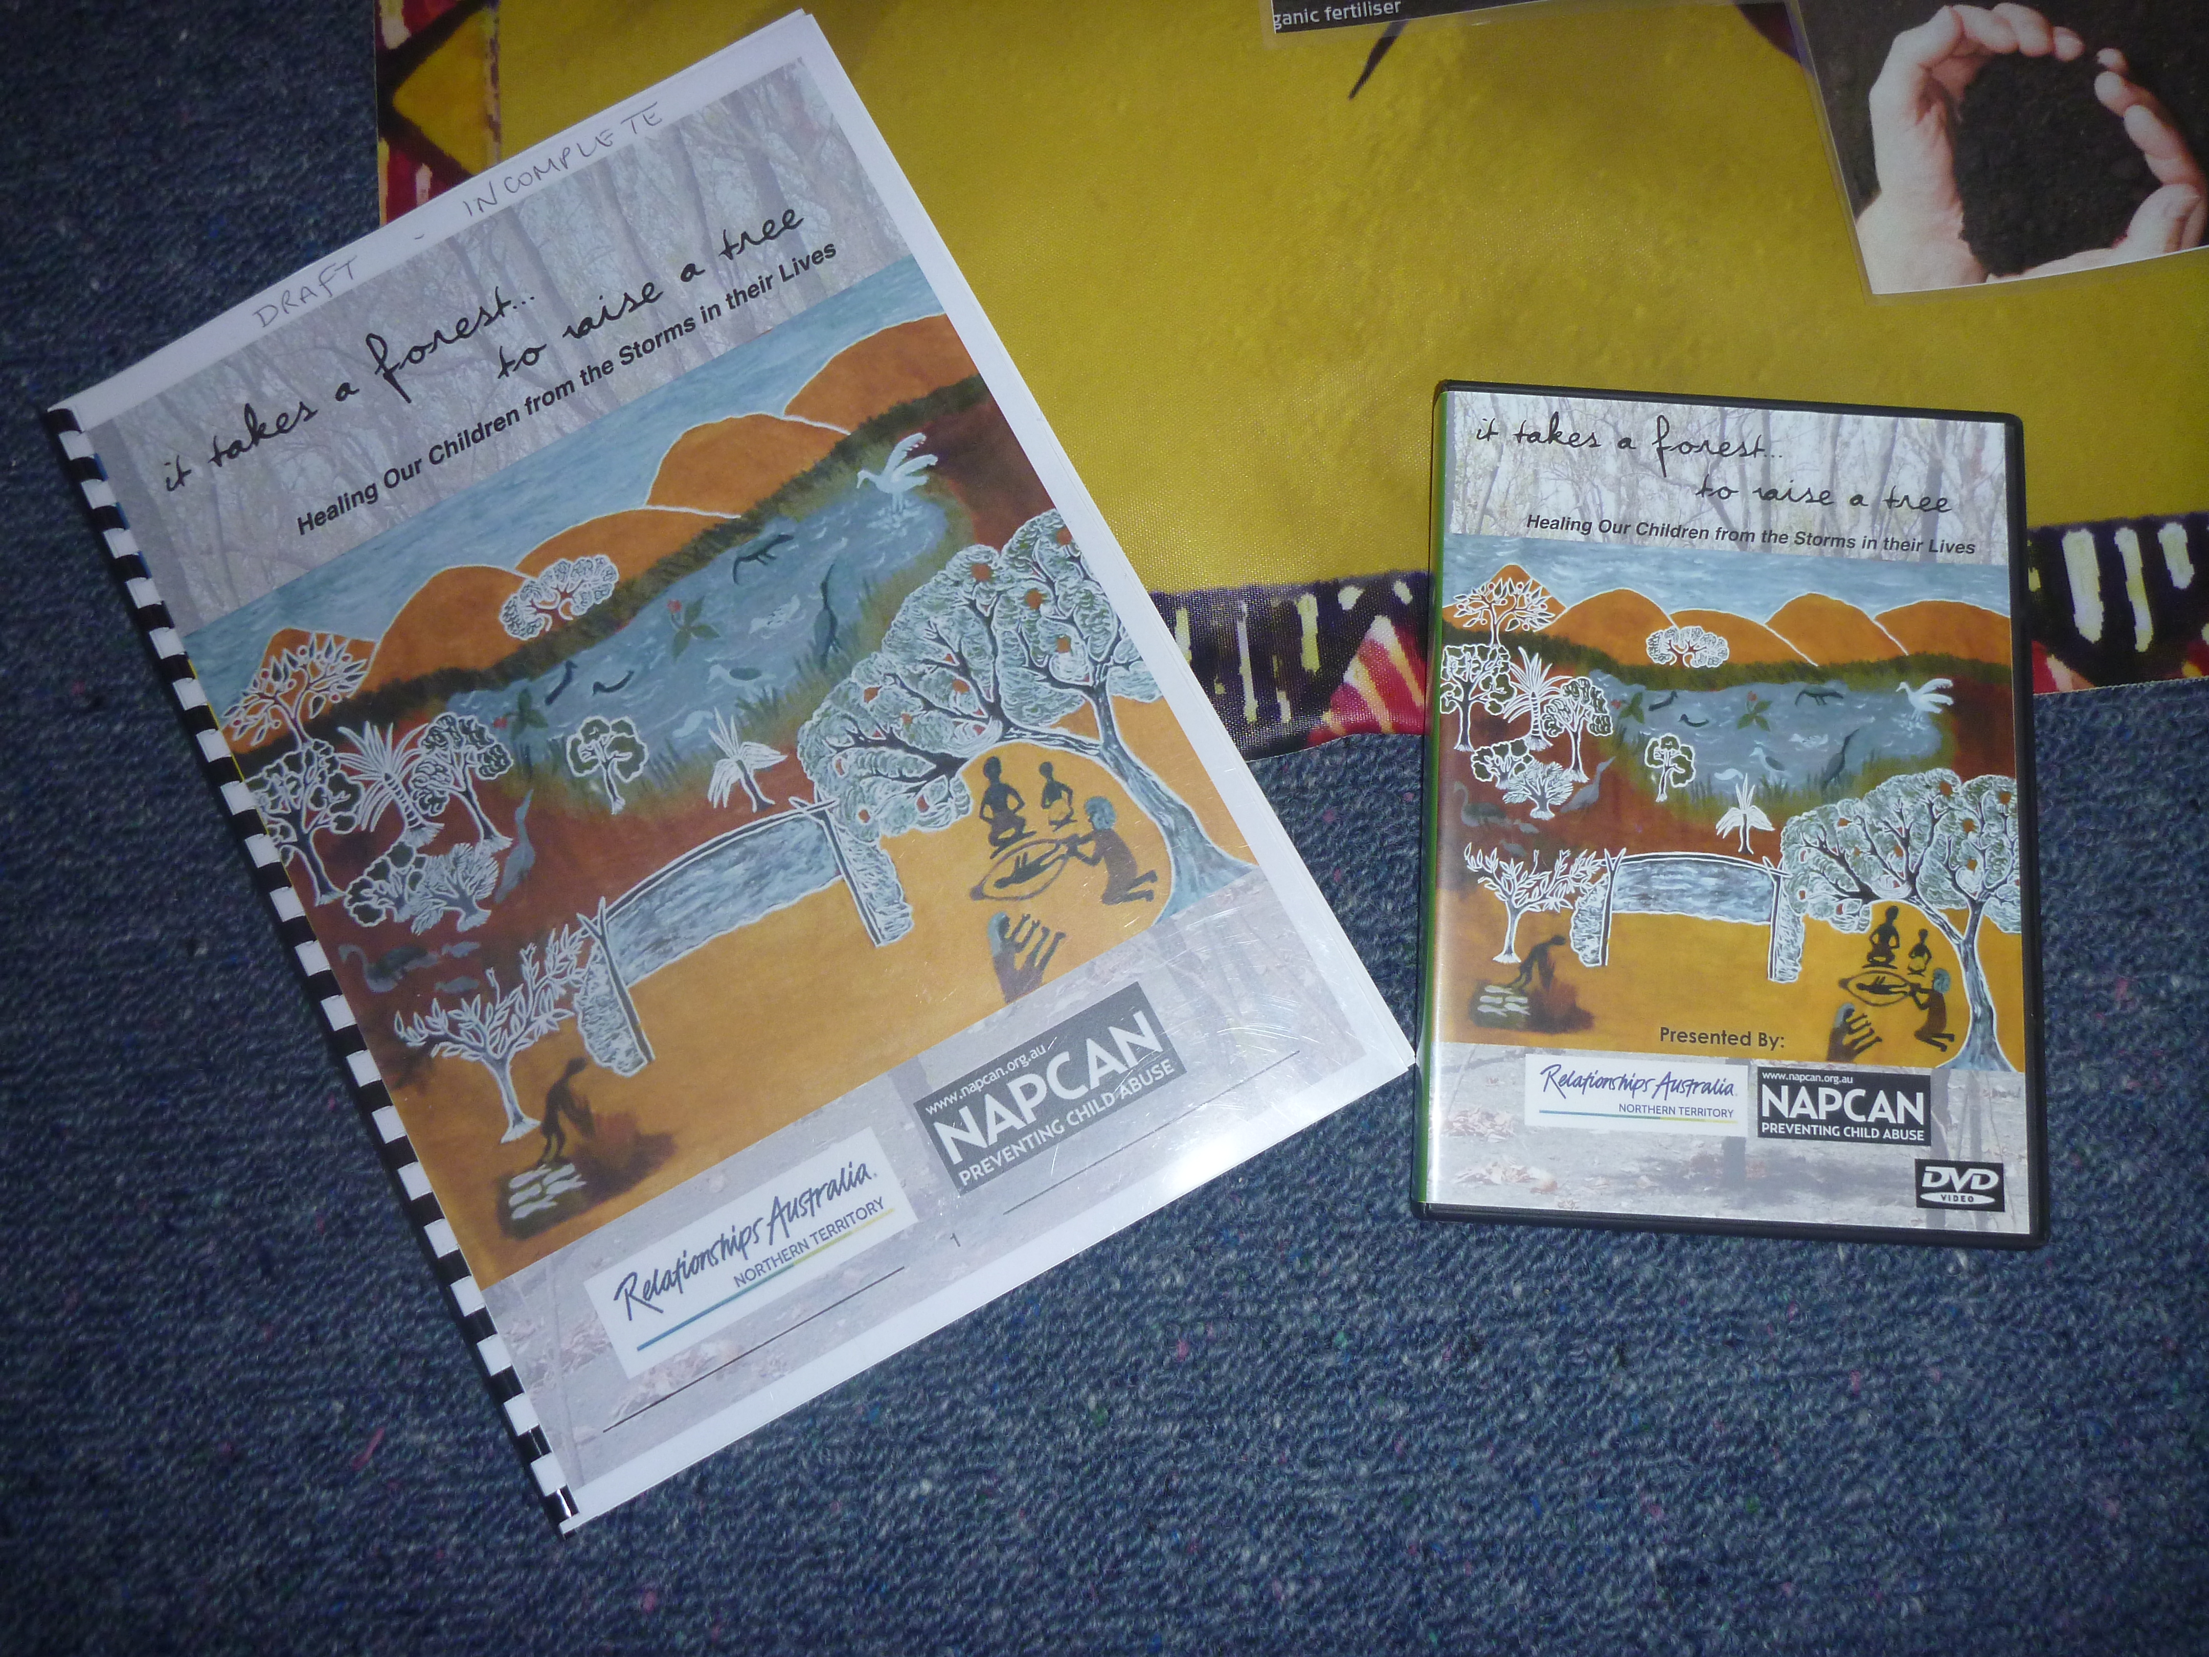Facilitators manual and DVD
- a Circle of Life mat to sit around with women in small groups
- a facilitators manual with key questions to guide the dialogue
- various picture cards used during the dialogue
- and a DVD of video stories.
Although the complete kit is not available to the general public, feel free to download the video stories below suitable for use in groupwork or individual counselling.
‘It Takes a Forest’ video Stories –
One Family Tree (https://www.youtube.com/watch?v=nEv8kx4fluc)
“One Family Tree” is a fictional story filmed in a remote Aboriginal community in the Northern Territory. The film shows how witnessing domestic violence can affect unborn babies and children of all ages, and the sorts of things families and communities do to help children heal. It may be a useful tool to spark a discussion with Aboriginal families, groups and communities.
The Seed of Life – Tiwi version (https://www.youtube.com/watch?v=0vNI83m2WWU)
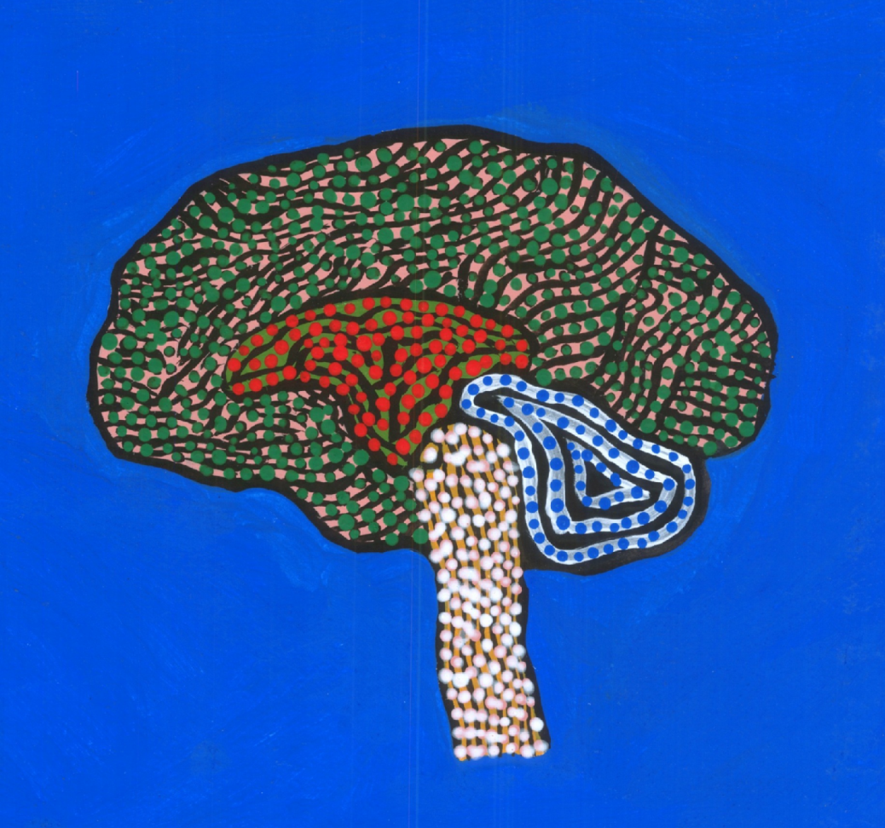
‘The Seed of Life’ tells a story about the harmful effects of trauma on the developing brain and explains why it is so important to protect children from an early age. Just like a seed must be cared for early in life to grow into a strong and healthy tree, the same can be said about the brain of a baby. This story is told in Tiwi language with English subtitles.
The Seed of Life – Yolŋu version (https://www.youtube.com/watch?v=g4QXUy_Y6Mo)
‘The Seed of Life’ tells a story about the harmful effects of trauma on the developing brain and explains why it is so important to protect children from an early age. Just like a seed must be cared for early in life to grow into a strong and healthy tree, the same can be said about the brain of a baby. This story is told in Djambarrpuyŋu language with English subtitles.
‘Funding
Development of the talking tool was made possible through a ‘Linked Up For Safe Kids’ grant from NAPCAN through funding made available from the NT Office of Children and Families and SNAICC.
Healing Our Children’ project proposal
…Metaphorically Speaking is seeking interest from partners wishing to collaborate to support the healing of remote Indigenous communities through the “Healing Our Children” project. An innovative initial trial of the program will provide training, mentoring and support to Tiwi workers, to support vulnerable and at-risk Aboriginal women with children who are living with violence or other trauma. If you are interested in joining with us to work out how we can best mobilise this healing and trauma prevention work please contact Lucy Van Sambeek on 0417 927 657 or lucy@metaphoricallyspeaking.com.au
More Information
Go to http://www.metaphoricallyspeaking.com.au/for-investors/

